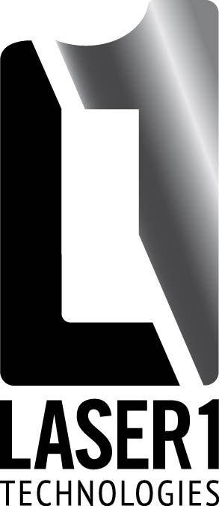
Laser 1 Technologies, Inc.
1777 Oakdale Ave. PH: 651-451-3444
West St. Paul, MN 55118 FX: 651-451-9397
Website: www.laser1tech.com

Credit Application
General information:
Complete Business Name:
Billing address:
Shipping address:
Telephone: Fax:
Business Type: Sole Prop. / Corp. / Partner Year Established:
President:
Federal Tax ID #:

Accounts Payable Contact:
Email Invoices: Y / N Email:

Shipping Contact:
Over Shipment Percentage:
Shipping days early allowed prior to purchase order request date:

Shipping pre-pay and add or collect, preferred carriers for collect:
Do you accept partial purchase order shipments (if there are multiple parts on the same purchase order)? Y / N
Do you accept multiple purchase orders on the same packing slip? Y / N
Accepting backorders: Y / N
Any special packaging requirement:

Bank Reference:

Name:
Address:
Phone:
Account#:

Trade or Vendor References: (please list at least 3)

Name:
Address:
Phone:
Fax/Email:

Name:
Address:
Phone:
Fax/Email:

Name:
Address:
Phone:
Fax/Email:

Name:
Address:
Phone:
Fax/Email:

The above information is for the purpose of obtaining commercial credit and is true, correct and complete. Creditor is hereby expressly authorized to investigate the references herein listed. Applicants signature attests to applicant’s financial responsibility, ability and willingness to pay Creditor invoices in and further agrees that in the event of a buyer dispute Laser 1 Technologies may institute and action for collection of any amount due from buyer in any court of competent jurisdiction and buy consents to jurisdiction and venue of the courts located in Saint Paul, Minnesota.

Print Name Title

Signature Date

